**------------------------------------------------------------------------------------------------------------------------------------------**

**TASK1: LOGIN and Registration Activities**

**------------------------------------------------------------------------------------------------------------------------------------------**

1. Created 3 Activities as below under project named “Lab3”

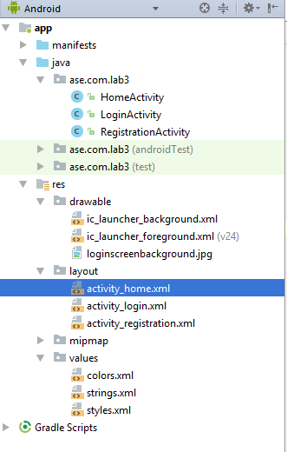

1. Now, Developing a “**LOGIN**” screen,
2. Adding a Background First,

Copied a Image from Local and pasted in “drawable” folder and used that in activity_login.xml file as below,

**android:background="@drawable/loginscreenbackground"**

1. Now, adding a Text to UI to say it’s a Login Screen using Different Attributes i.e. gravity ‘center’ for Center Alignment of Text, adding color to Text, TextStyle to make text bold,Italic.

<**TextView  
 android:id="@+id/textView"  
 android:layout_width="wrap_content"  
 android:layout_height="wrap_content"  
 android:layout_alignParentTop="true"  
 android:layout_centerHorizontal="true"  
 android:layout_marginTop="44dp"  
 android:gravity="center"  
 android:text="Welcome to Login Screen !!"  
 android:textAppearance="@style/TextAppearance.AppCompat"  
 android:textColor="@color/colorAccent"  
 android:textSize="20sp"  
 android:textStyle="bold|italic"** />

1. Added Input fields for Username and Password like below,

<**EditText  
 android:id="@+id/loginusername"  
 android:layout_width="wrap_content"  
 android:layout_height="wrap_content"  
 android:layout_alignEnd="@+id/textView"  
 android:layout_below="@+id/textView"  
 android:layout_marginTop="80dp"  
 android:ems="10"  
 android:inputType="textPersonName"  
 android:background="@android:color/background_light"  
 android:hint="Email Address"**/>  
  
<**EditText  
 android:id="@+id/loginpassword"  
 android:layout_width="wrap_content"  
 android:layout_height="wrap_content"  
 android:layout_alignStart="@+id/loginusername"  
 android:layout_below="@+id/loginusername"  
 android:layout_marginTop="28dp"  
 android:background="@android:color/background_light"  
 android:ems="10"  
 android:hint="Password"  
 android:inputType="textPassword"** />

1. Now creating Image Assets for Username and Password Textboxes by

Right Click on ‘drawable’ folder 🡪 New 🡪 Image Asset 🡪 Select ‘Action Bar and Tab Icons’ under ‘Icon Type’ dropdown 🡪 Click on ‘Clip Art’ Image [Set Padding to 15%]

Then we can search for Required images and add them which will be created under drawable folder.

Adding them to username, password by using below code.

**android:drawableLeft="@drawable/user_email"**

**android:drawableLeft="@drawable/user_password"**

1. Adding a LOGIN button now,

<**Button  
 android:id="@+id/login"  
 style="@android:style/Widget.Material.Button.Colored"  
 android:layout_width="wrap_content"  
 android:layout_height="wrap_content"  
 android:layout_below="@+id/loginpassword"  
 android:layout_centerHorizontal="true"  
 android:layout_marginTop="28dp"  
 android:text="Login"  
 android:textColor="@android:color/background_dark"  
 android:textSize="14sp"** />

Now, UI will look like below:

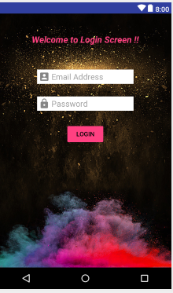

1. Now, We will create a Register Button, with some text infront of the button.

<**TextView  
 android:id="@+id/registrationtext"  
 android:layout_width="wrap_content"  
 android:layout_height="wrap_content"  
 android:layout_alignParentStart="true"  
 android:layout_below="@+id/login"  
 android:layout_marginStart="28dp"  
 android:layout_marginTop="70dp"  
 android:gravity="center"  
 android:text="Haven't Registered Yet ?"  
 android:textColor="?attr/colorBackgroundFloating"  
 android:textSize="16sp"  
 android:textStyle="bold"** />  
  
<**Button  
 android:id="@+id/registerbutton"  
 style="@android:style/Widget.Holo.Button"  
 android:layout_width="wrap_content"  
 android:layout_height="wrap_content"  
 android:layout_alignBaseline="@+id/registrationtext"  
 android:layout_alignBottom="@+id/registrationtext"  
 android:layout_alignEnd="@+id/loginpassword"  
 android:text="Register"  
 android:textColor="@android:color/holo_orange_dark"  
 android:textSize="15sp"  
 android:textStyle="bold"** />

1. Added a message text which is Invsible, & this text will come from JAVA layer (If any errors in Login) and will be displayed in UI.

**UI:**

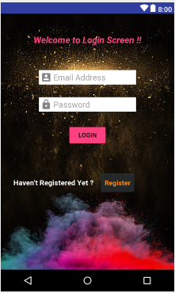

1. Added a ‘OnClick’ functionality for ‘Login’ button, which will call JAVA layer and few basic validations are done here for now.

Firstly, adding below line of code for Importing commonlangs jar:

compile **'org.apache.commons:commons-lang3:3.6'**

JAVA Code:

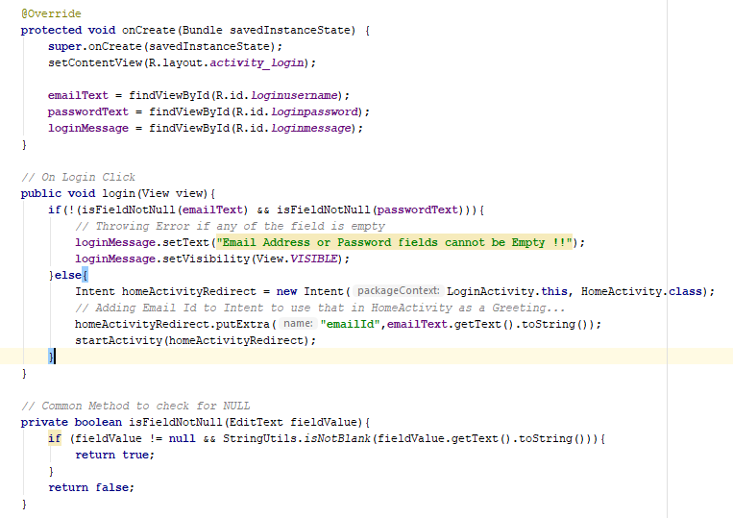

Error Scenario in Emulator if Login is clicked with Empty Fields:

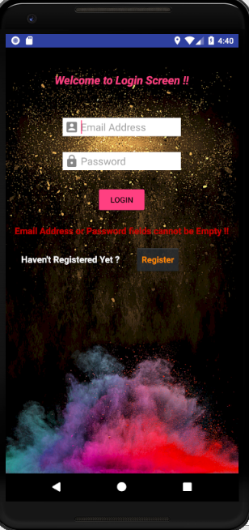

1. Now adding “Facebook” SignIn using Oauth 2.0

Reference: <https://developers.facebook.com/>

LogIn to the above site, Created a Application and we need to select a Platform to which we will use this FaceBook login,

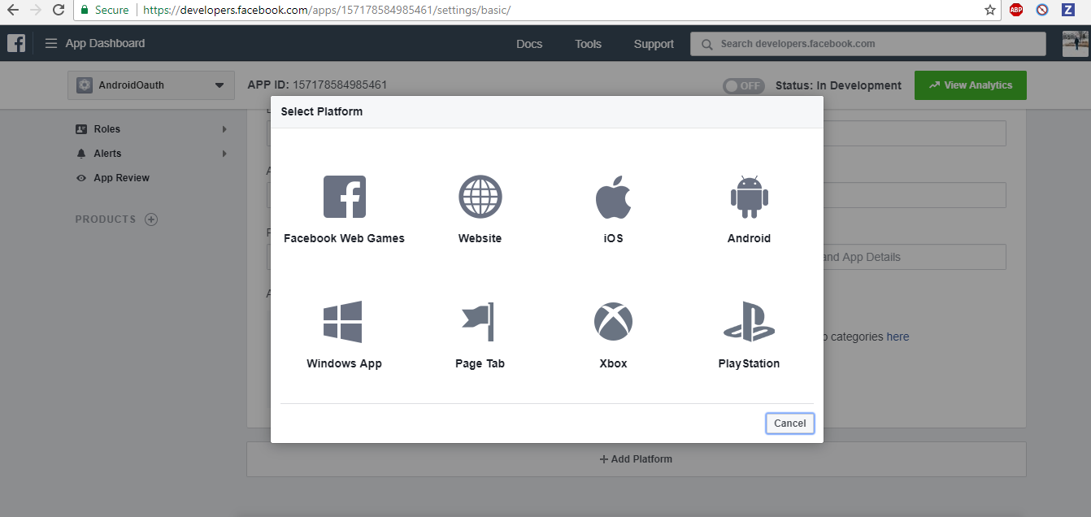

Once platform is added, Adding Required things like below,

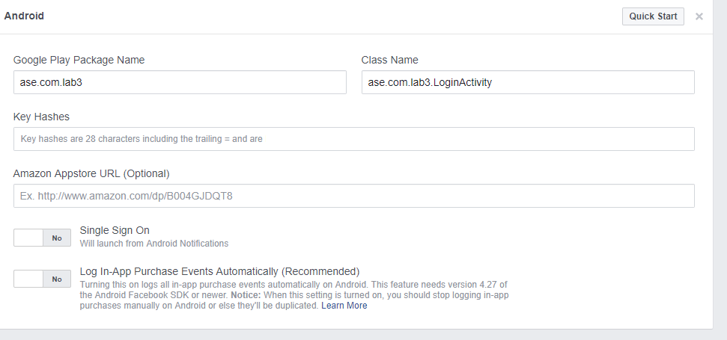

Key Hashes will be from Gradle by running ‘report’, SHA1 value needs to be copied from this to above ScreenShot mentioned.

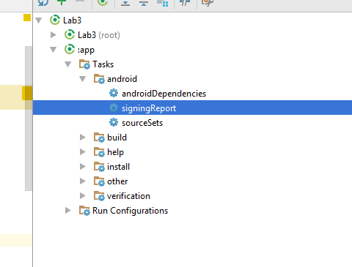

Once the configuration is done, we need to follow below steps,

**Adding Activity:**

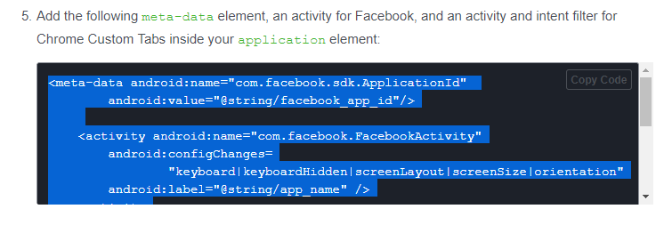

We need to need our facebook_appId, facebook login protocol scheme in our application. Added them as below in strings.xml..

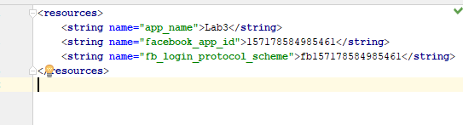

Adding below JAR in gradle.app,

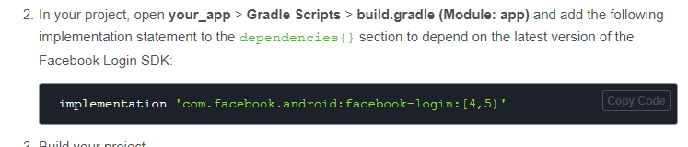

As per Facebook change log, latest version Is 4.30.0:

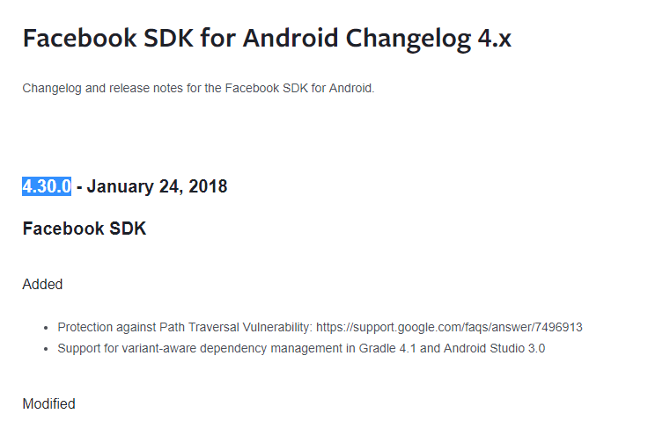

Adding below lines of code in Login. Activity xml :

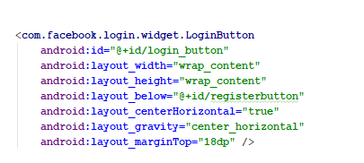

Made changes in JAVA:

Initialization of CallbackManager is done which is used for Facebook Authentication 🡪

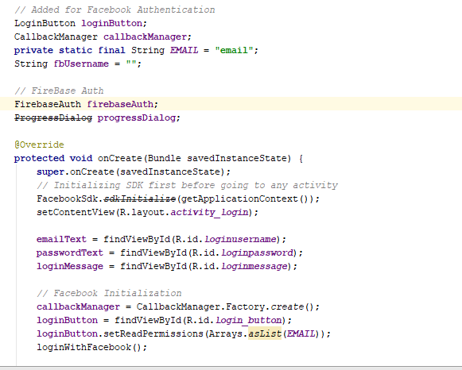

Created a method loginWithFacebook, which is called and uses LoginManager to see the login result.

It have 3 methods that are overrided,

1. onSuccess 🡪 If the facebook login is Successful, this method is called.
2. onCancel 🡪 If user prompts to stop the login, this method will be called, so showing a Text message here to say that user cancelled the login.
3. onError 🡪 If any exception occurred, we will showing the reason for the error in UI.

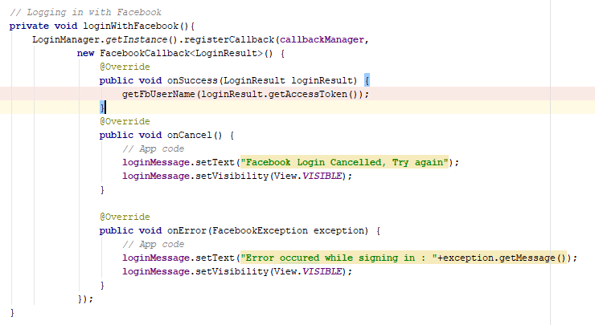

Using GraphRequest to get the Username from Facebook,

First we will be setting Read Permissions to Facebook, and we will use Graph Request to fetch the username alone from the JSON. Once GraphRequest is completed, we will set the Username to Intent and we will start a Redirect Activity to HomeActivity.

If any exception occurred, we will be showing a Text with Error.

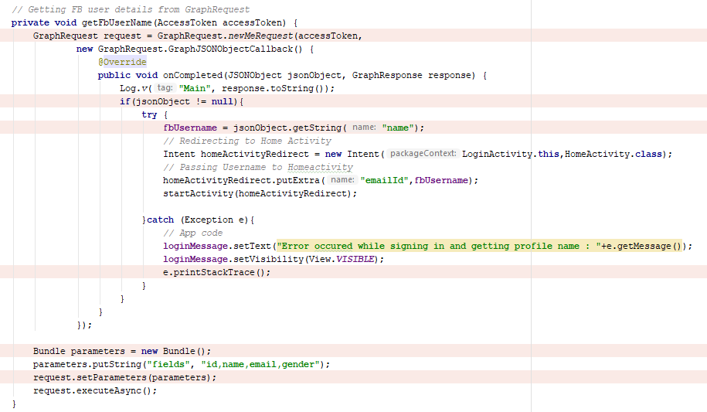

UI look:

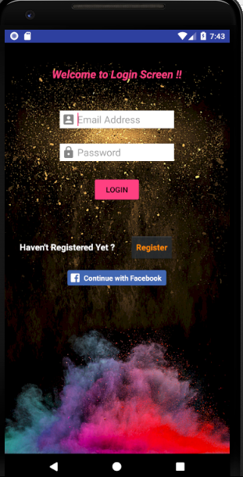

On Login with Facebook Click:

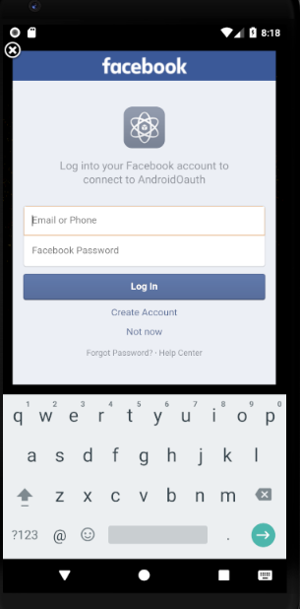

Giving Credentials:

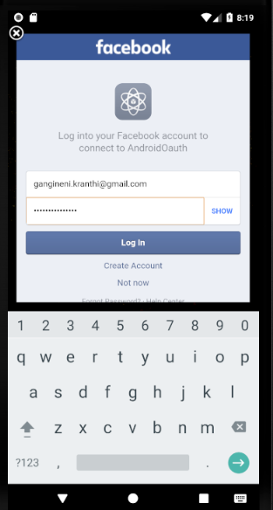

On Login Click, (I have a Security check where I need to enter security code), it prompted me to enter security code:

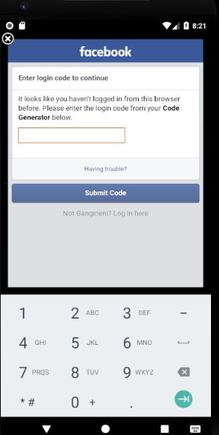

On Successful Code Submission,

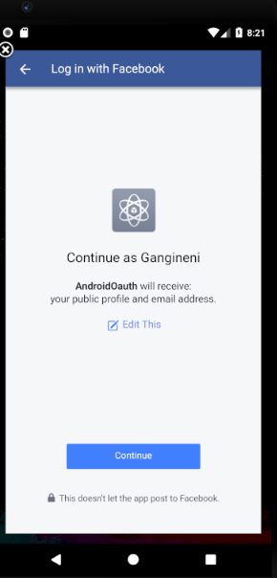

By Clicking Continue,

We can be able to login to Home Activity Successfully for which the Developed UI will look like below,

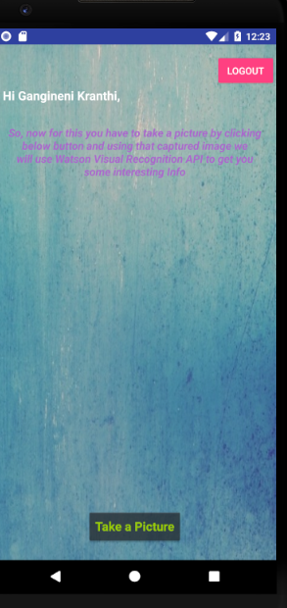

On Clicking Not Now/Cancelled, a message will be thrown like below:

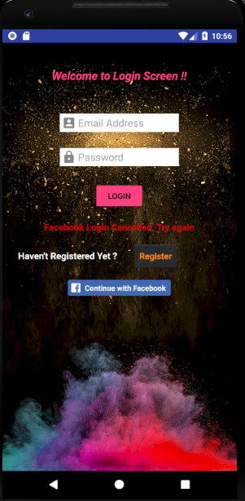

If Facebook User already exists and Opened app again, then Instead of showing Login Page again we will be leading the user to Home Activity using below code in LoginActivity.

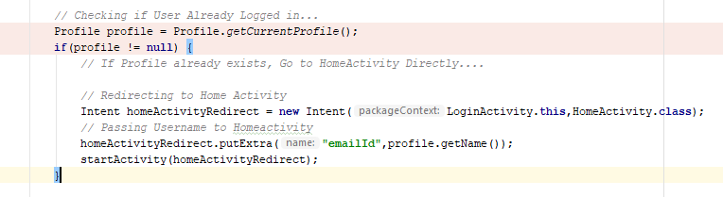

1. Now, Developing Register Activity, On Register Button click in Login Screen.
2. Registration Screen is comprised of fields 🡪 Username, Email Address, Password, Confirm Password, Login Button, Register Button, Reset Button.

**UI:**

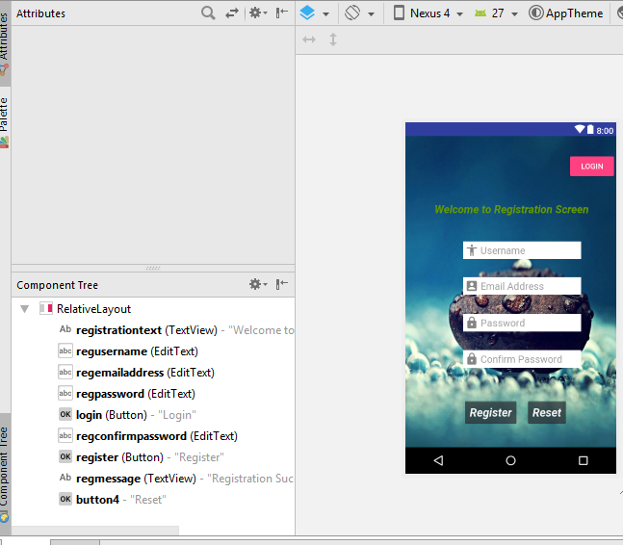

**Registration Text 🡪 Welcome Message**

**EditText Fields 🡪 Mandatory fields for Registration**

**Reset 🡪 To reset all the fields to empty**

**Register 🡪 Registration of user.**

**Login 🡪 To navigate to Login page.**

**Code Snippet:**

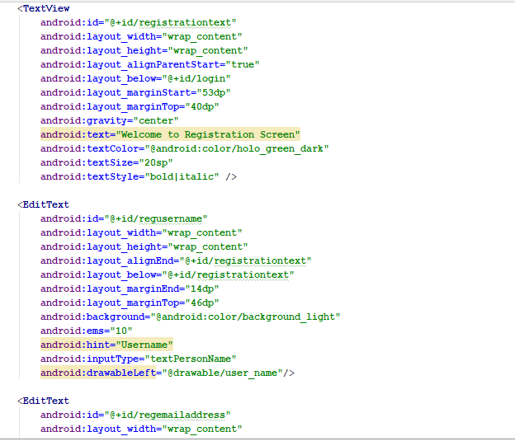

**JAVA Code:**

On Reset 🡪 Fields should be Resetted.

**public void** resetfields(View view) {  
 **regUserName**.setText(**""**);  
 **regEmailAddress**.setText(**""**);  
 **regPassword**.setText(**""**);  
 **regConfirmPassword**.setText(**""**);  
 **regMessage**.setText(**""**);  
 **regMessage**.setVisibility(View.***INVISIBLE***);  
}

Login Click 🡪 Redirect to Login Page will happen.

Register Button Click 🡪

We will be doing below validations on click of Register…

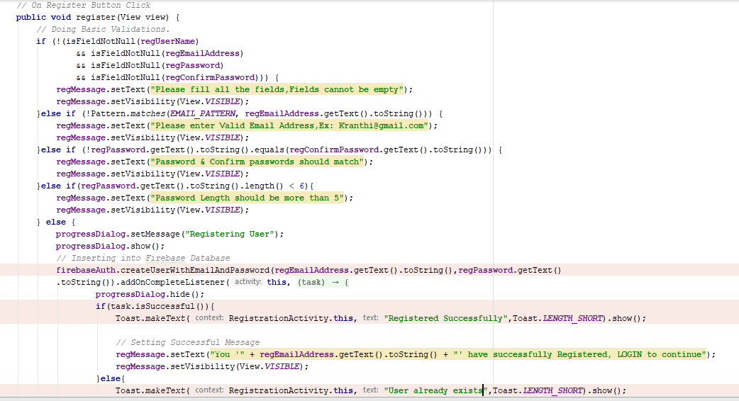

**Register UI in Emulator:**

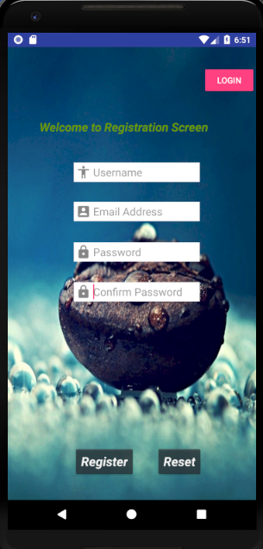

**Fields Empty:**

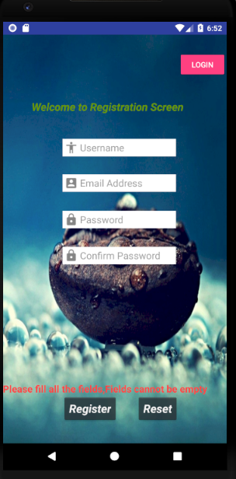

**Email Format Invalid:**

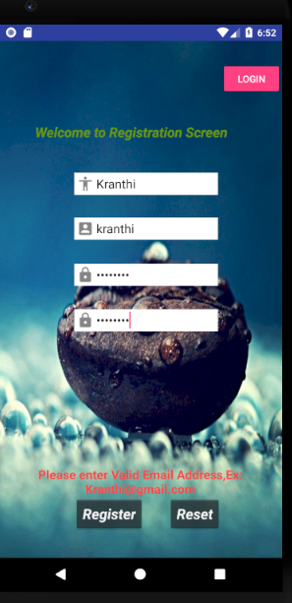

**Passwords Mismatch:**

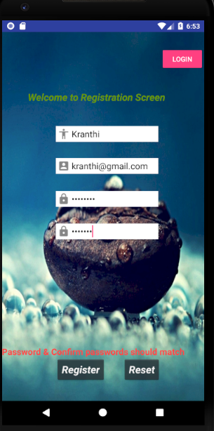

**Password Length Validation:**

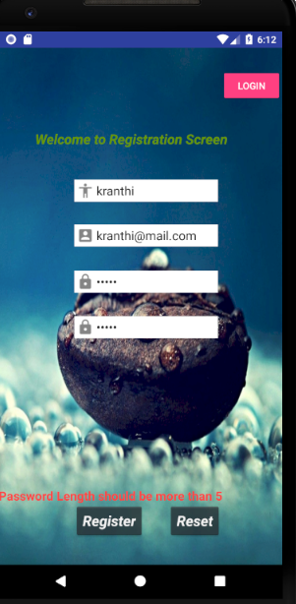

1. **Firebase Authentication Storage:**

**Now,** using Firebase Authentication we will be storing the Email Id and Password of the users who tries to register to this Application.

& When tried to login with the registered credentials we will be allowing the user to see the HomeActivity that is created.

Now, Into the Configurations….

Under Tools 🡪 Firebase

We will be configuring for Realtime Database setup which will import all the Required JAR’s for us.

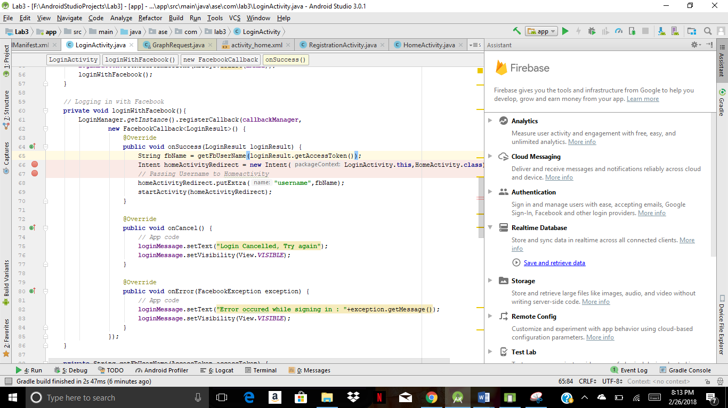

We need to connect our App to Firebase first,

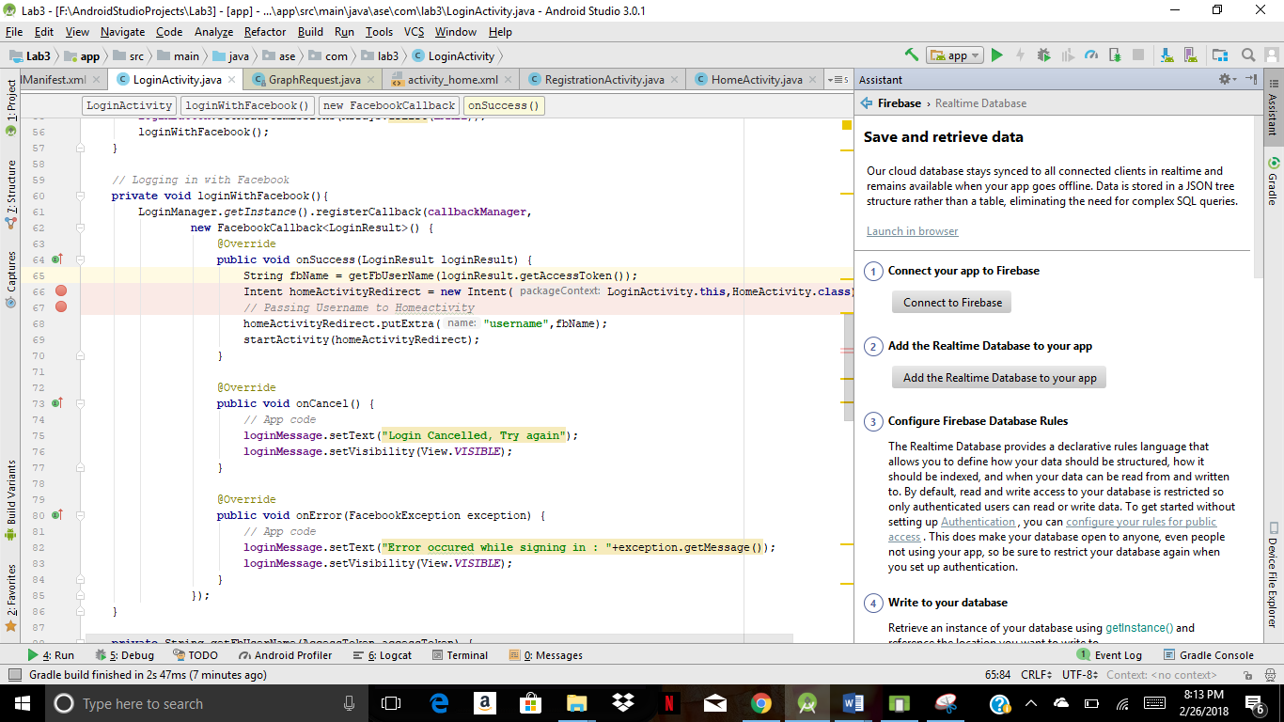

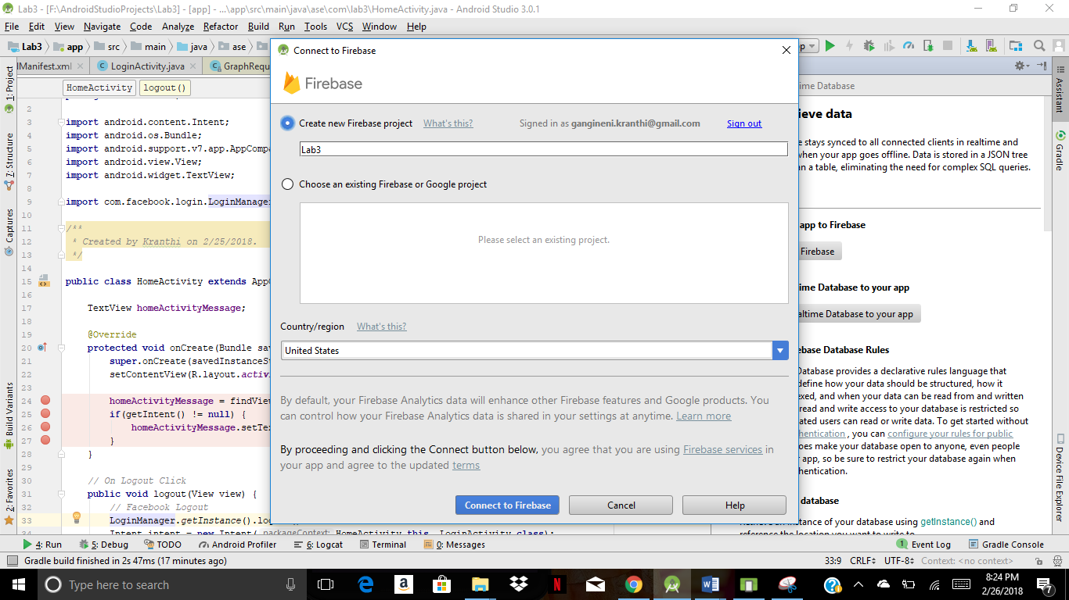

JAR dependencies…

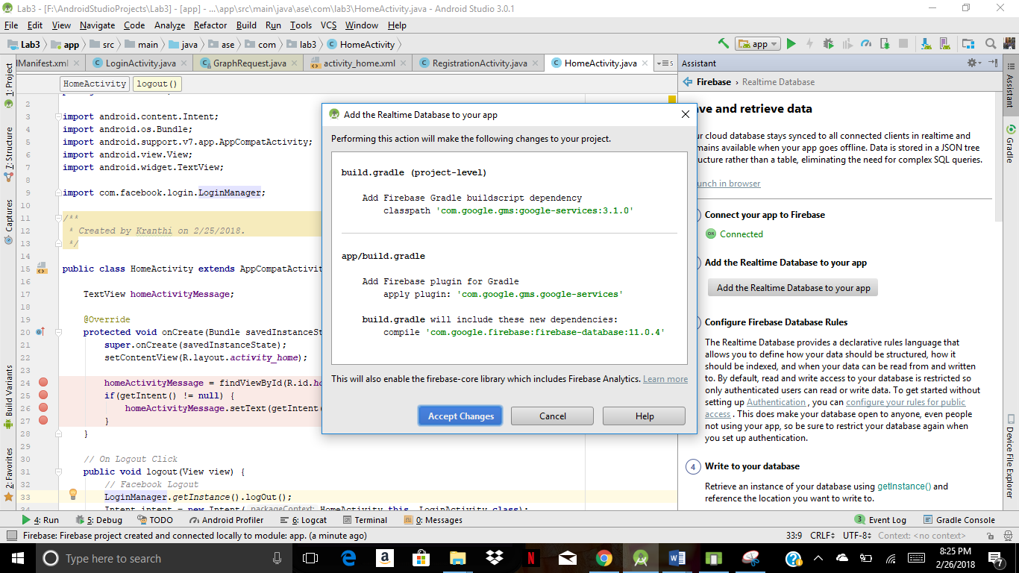

Once app is created for our gmail account, we need to do few changes like below..

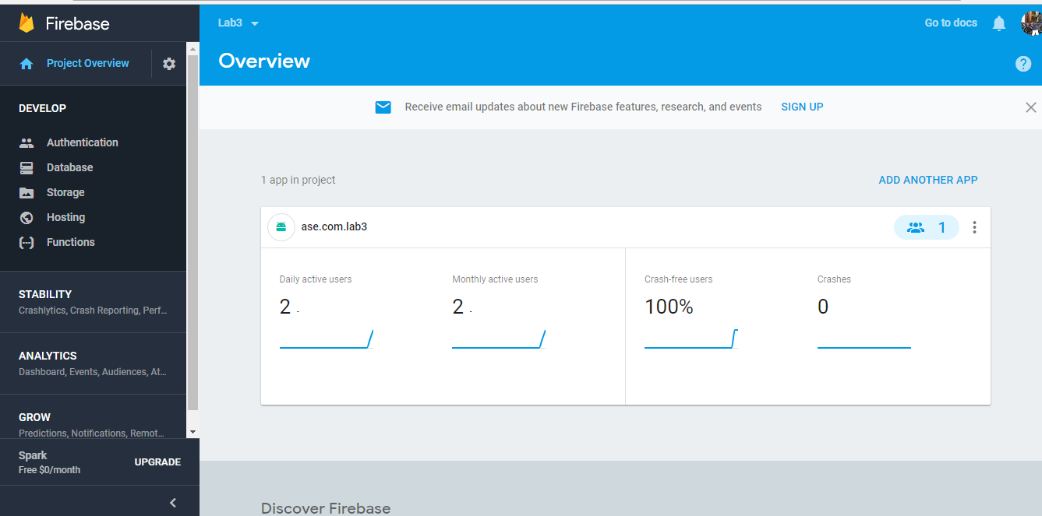

Enable Sign-In for required Authentication,

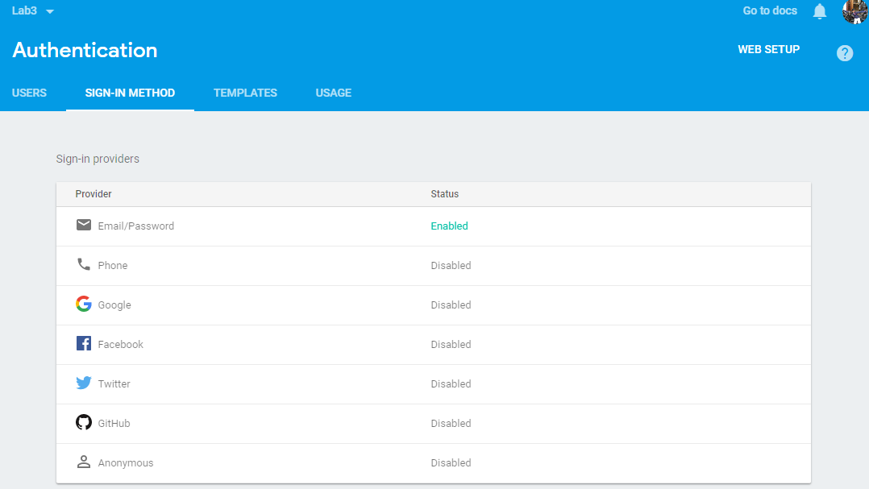

We need to change Rules for Real Time Database,

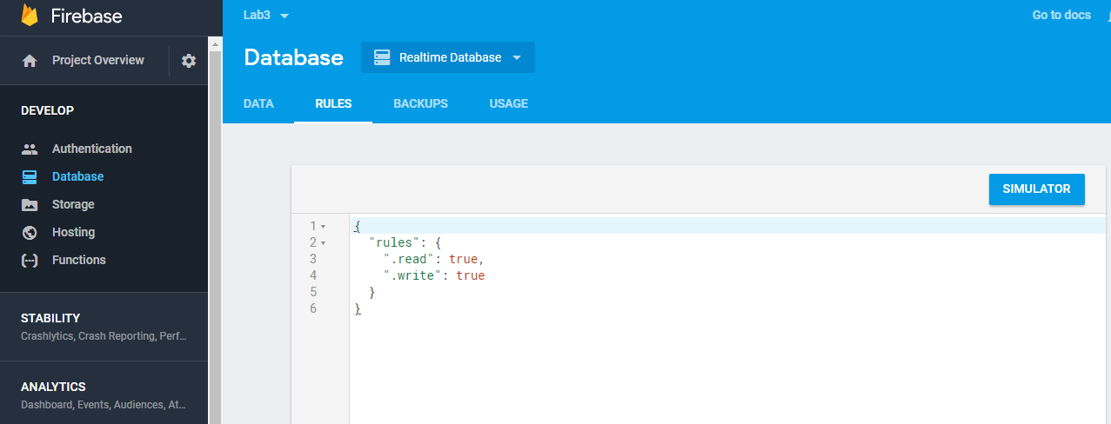

Once Configurations are done,

Below JAR is added in gradle.app,

compile **'com.google.firebase:firebase-auth:11.0.4'**

Then,

Code changes are made like below in Login and Registration activities…

Registration:

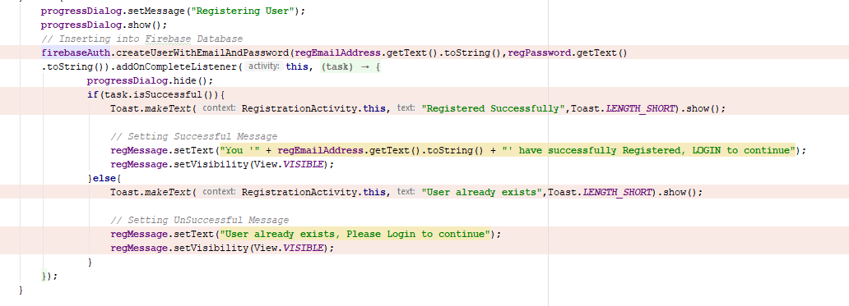

We will be using firebaseAuth createUserWithEmailAndPassword method to register the user.

A progress dialog will be shown when registering the user and hidden later.

Toast is made to say whether Registration is successful or not.

Login:

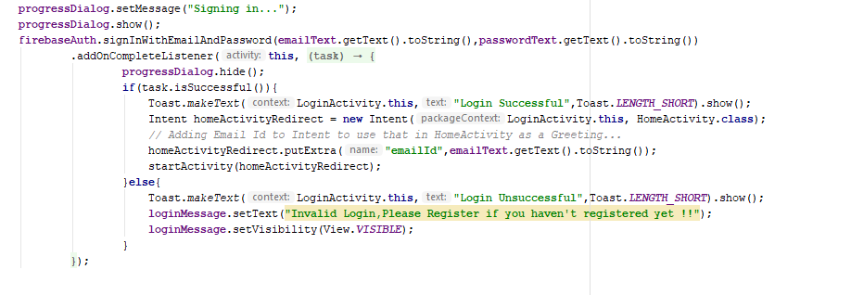

We will be using FirebaseAuth signIn method to check if the user exist or not.

If Task is Successful, we will be Login to HomeActivity. Else, error message will be thrown.

**Registering a New User with Firebase:**

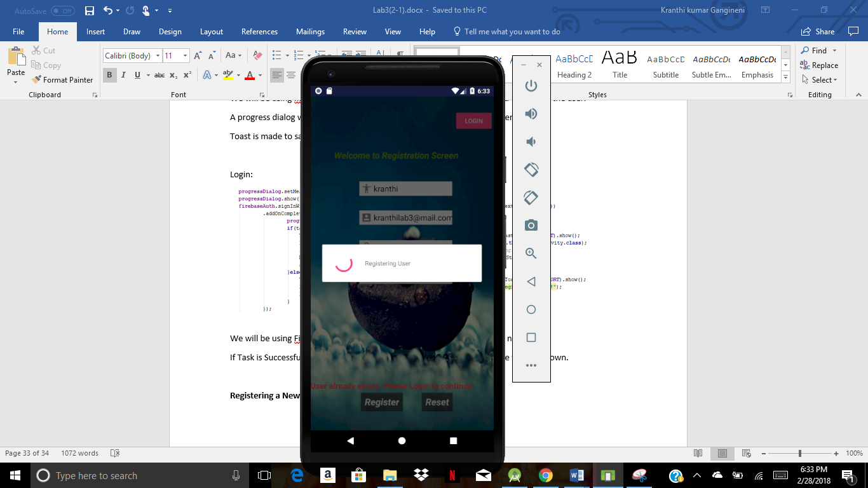

**Once Registration is done…**

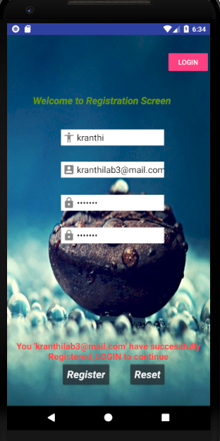

**If user** already exists…

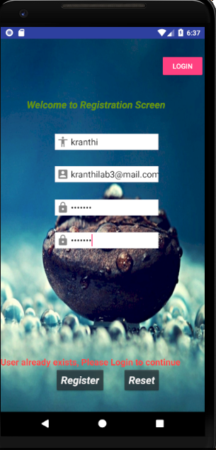

**Data** in Firebase Console…

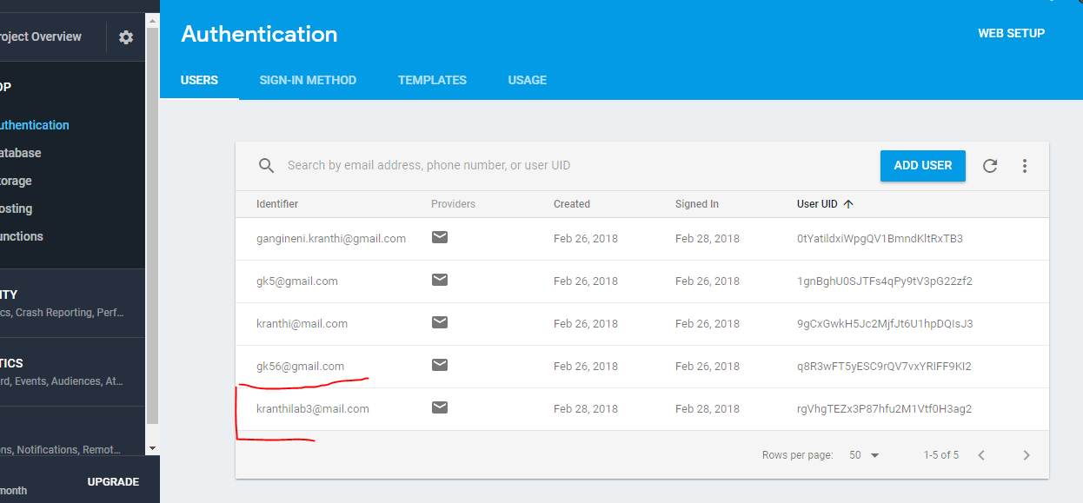

Now, we will try to Login with the Registered User,

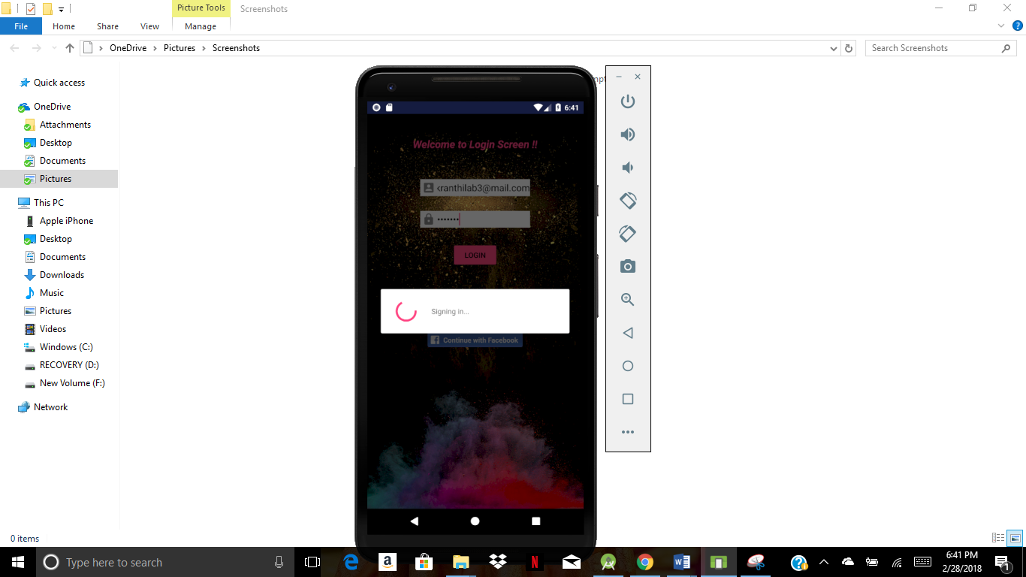

After Successful Login,

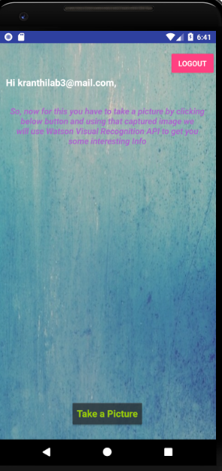

If Unsuccessful Login,

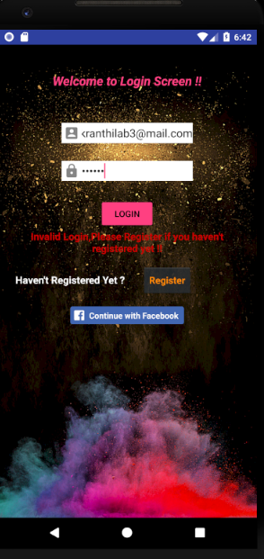

**----------------------------------------------------------------------------------------------------------------------------------------**

**TASK 2 & TASK 4 : Machine Learning API for HomeActivity**

**------------------------------------------------------------------------------------------------------------------------------------------**

For these tasks we will be using Smartphone Camera Feature for Capturing an Image and using that Image we will use Watson Visual Recognition API to detect the Image which we have Taken….

Firstly, Setup for Camera…

1. Camera:

Adding Permissions for Camera,

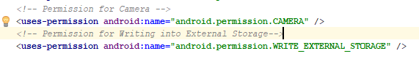

Home Activity Xml (Part of the code) is shown below,

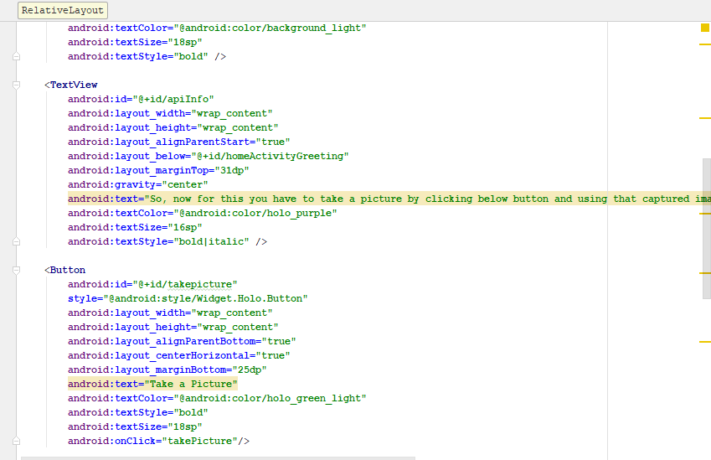

In this for Take a Picture,we have a OnClick function for which we will have interaction with JAVA…

*// On Click of Take Picture...***public void** takePicture(View view) {  
 *// To take Picture..* **cameraHelper**.dispatchTakePictureIntent();  
}

Where CameraHelper is initialized in “onCreate” method.

In the app run, it will ask for Permissions first when the Button is clicked, then only we can be able to take pictures..

Now, into Watson API part where we gonna use this image to show in UI and use it to get Visual Recognition details.

First, Configurations…

We should generate API key first using Watson Visual Recognition

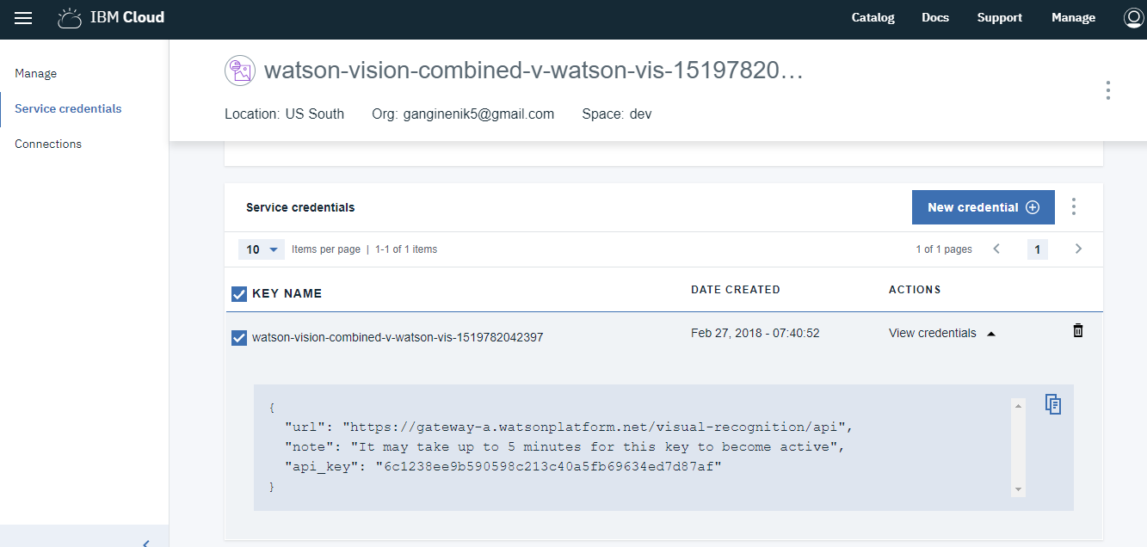

API key is added in ‘strings.xml’

*<!-- Watson Vision API Key -->*<**string name="watson_api_key"**>6c1238ee9b590598c213c40a5fb69634ed7d87af</**string**>

This key will be used in JAVA.

Adding Required JARs in gradle.app

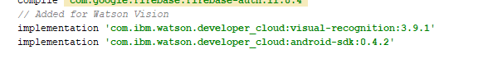

Into Coding now…

First we will Instantiate the Required class (VisualRecognition) in our case.

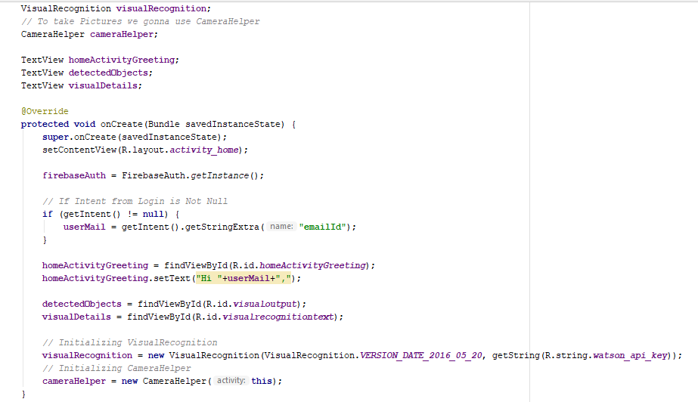

Now we need to show the Image on UI and get the visual recognition details…

*// Extracting Picture in form of BitMap Object***final** Bitmap bitmap = **cameraHelper**.getBitmap(resultCode);  
**final** File file = **cameraHelper**.getFile(resultCode);  
  
*// Setting the Preview*ImageView imageView = findViewById(R.id.***imagepreview***);  
imageView.setImageBitmap(bitmap);

Using above code to get the BitMap and File once the Picture is Take.

BitMap is set to the ImageView to show it on UI..

Below is the main code to fetch the Visual Recognition Details:

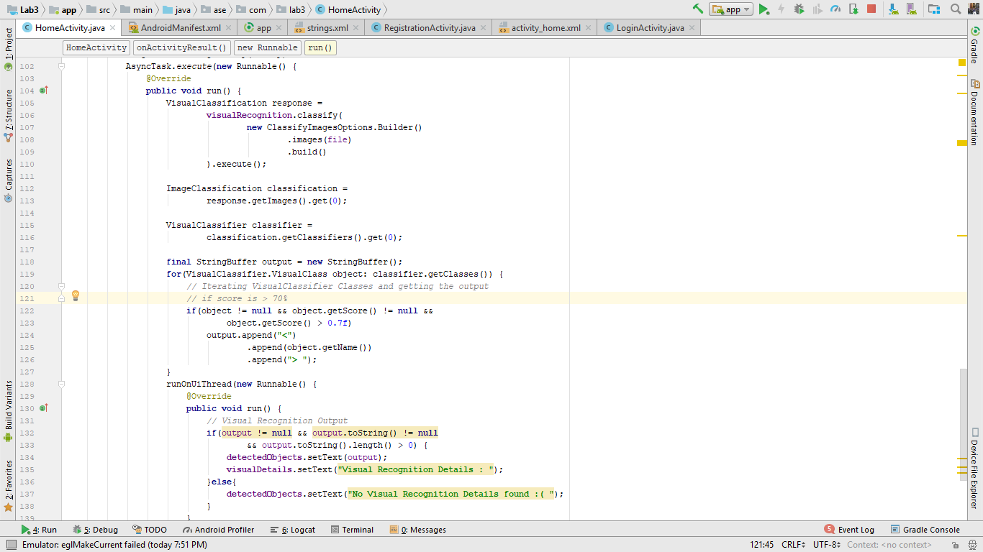

Passing the Image to classify method in code to fetch the details from Image.

“ImageClassification” works on multiple images at a time, as we are currently working only on 1 Image,we will be using “.get(0)”

Looping Visual Class Objects and displaying the names of only whose score is > 70% and displaying the output finally.

If no data found, then a message will be thrown as shown above.

Running the HomeActivity in Android Smartphone gave below outputs:

After logging in 🡪

On Click of ‘Take a Picture’ 🡪

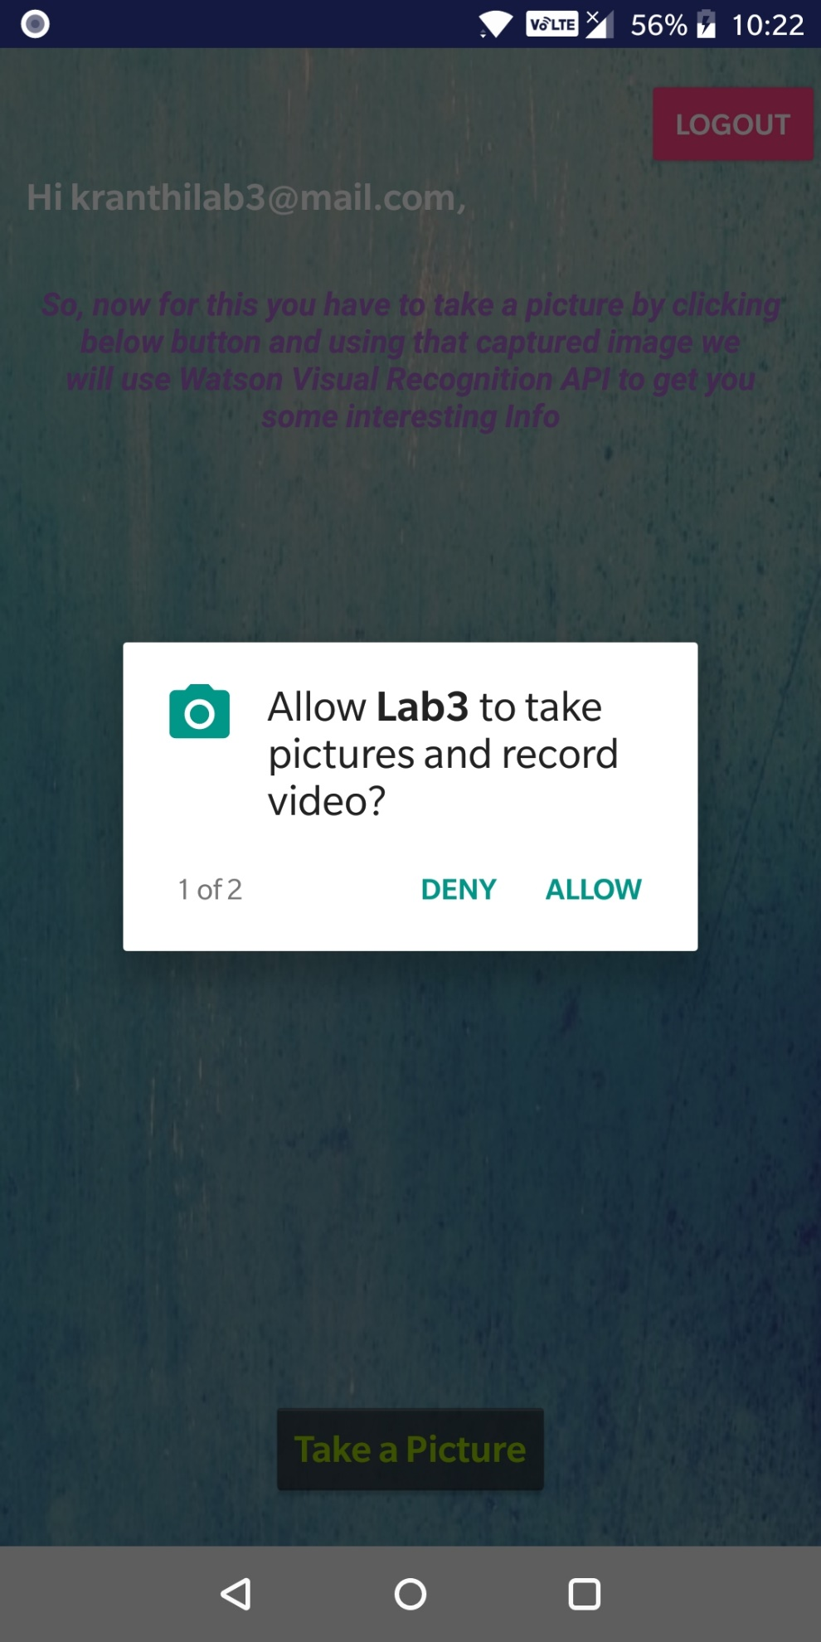

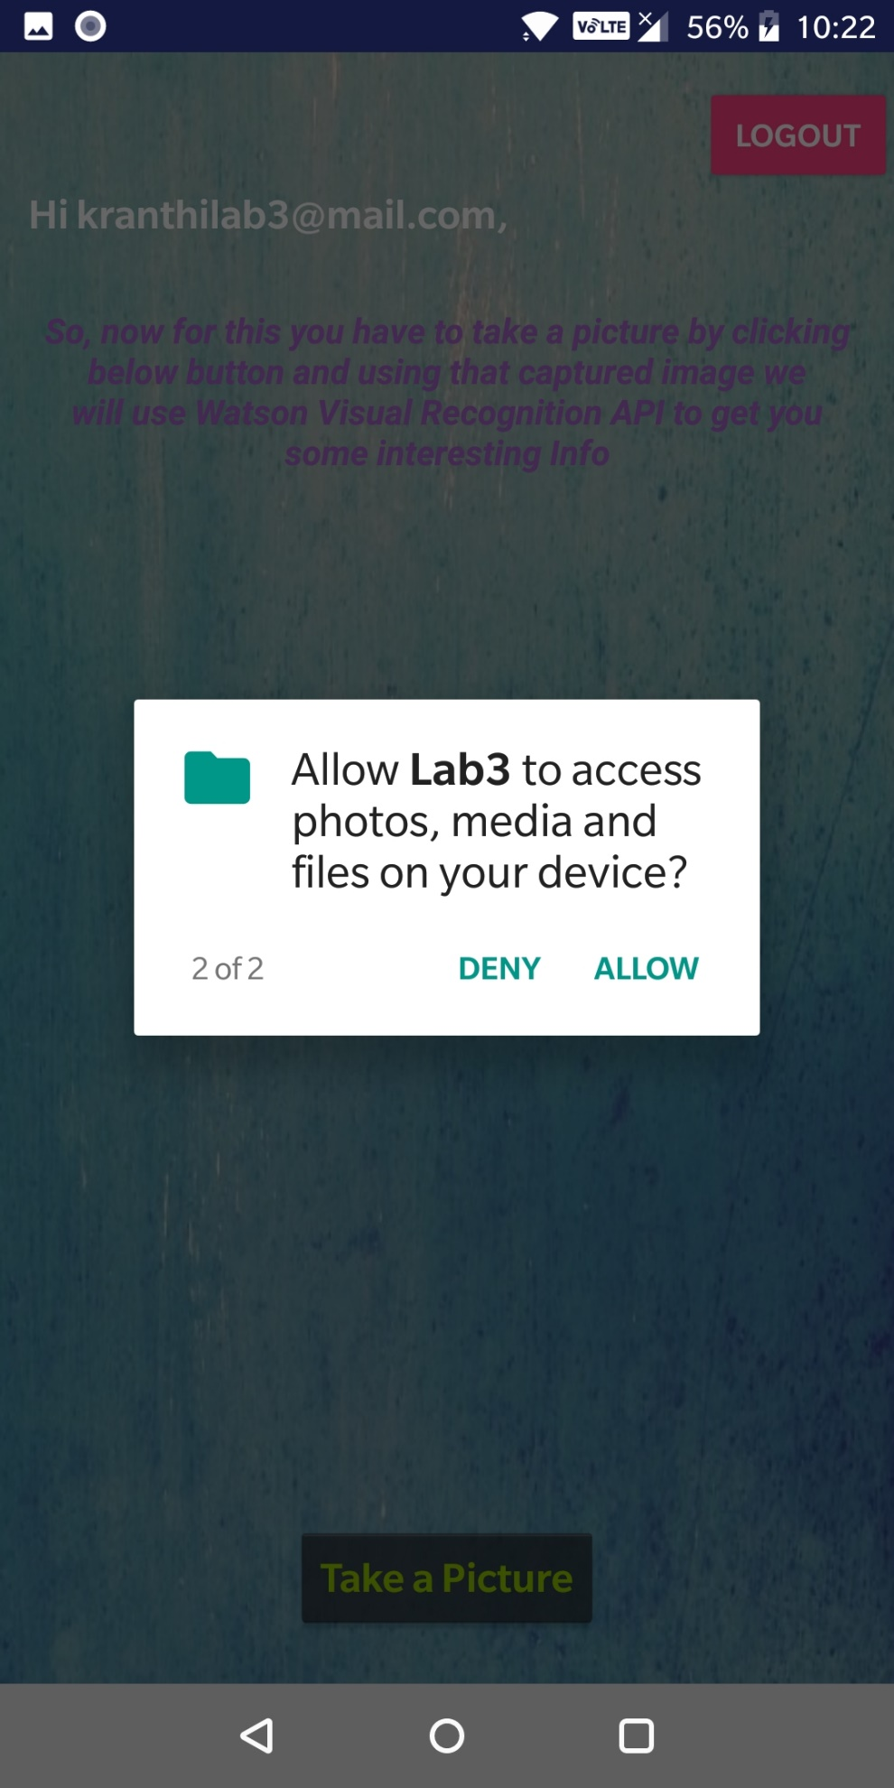

Taking Picture after allowing Access 🡪

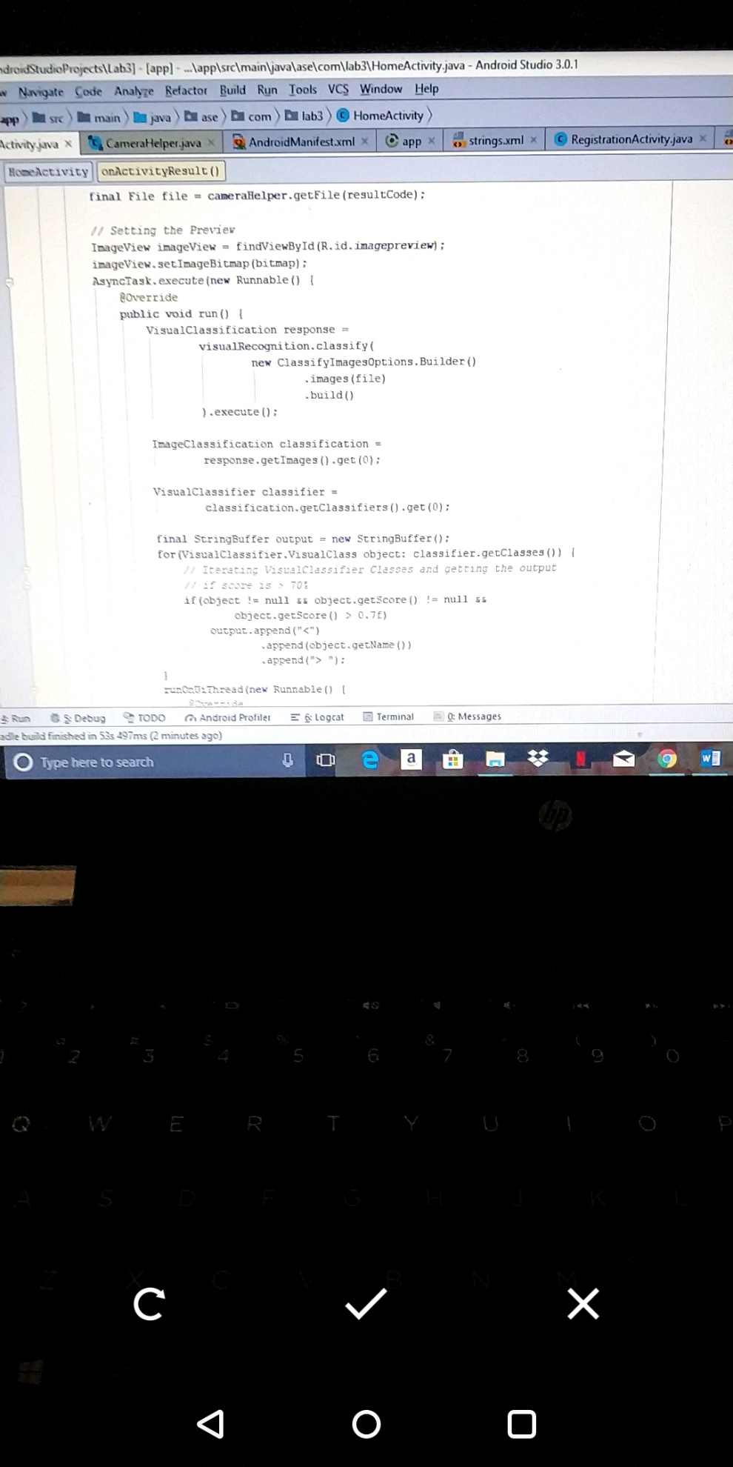

On Click of ‘Ok’ 🡪 Image taken is read by Watson Visual Recognition and details of the Image are showed as below.

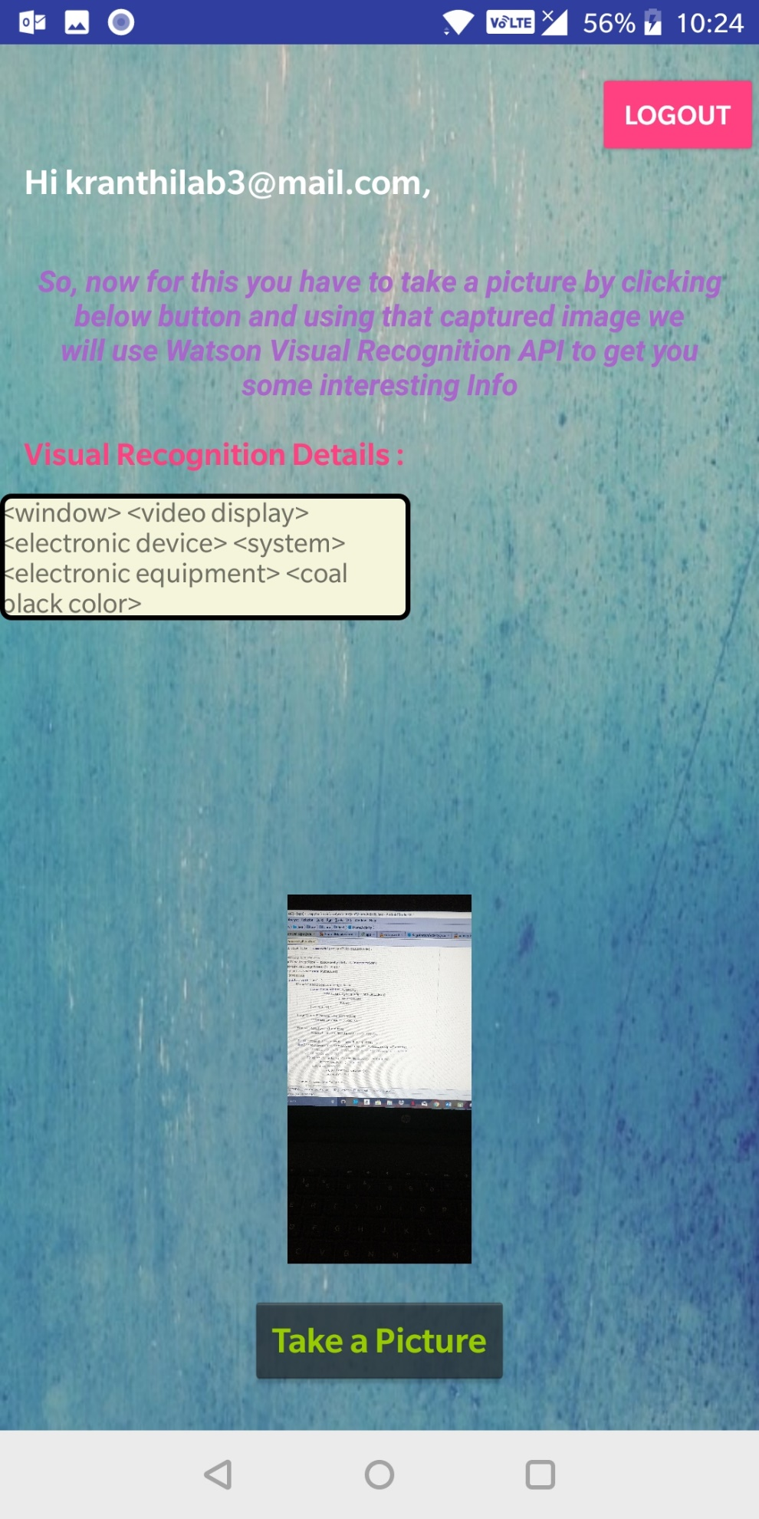

**Task 5 :**

Created all the activities properly with proper backgrounds and Validations.

Used Firebase Authentication, Watson Visual Recognition API, Camera access..

Transitions are properly present between Login 🡪 Register page

Register 🡪 Login Page

Login 🡪 Home Page

HomePage 🡪 Login Page [Using LOGOUT button]

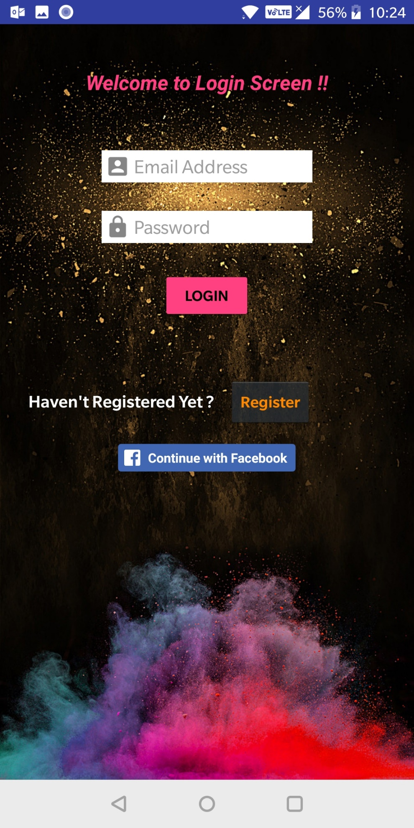

Bibliography: <https://developers.facebook.com/docs/facebook-login/android>

<https://www.youtube.com/watch?v=0NFwF7L-YA8>

<https://www.ibm.com/blogs/watson/2017/04/build-unique-visual-recognition-apps-watson-4-easy-ways-get-started/>